VIC User Guide
Vital Information Center

Written by: David F. Leigh
Project Manager
Consulting Systems Analyst
Cratchit.org



Cratchit.org
204 Camelot Dr, Union, SC 29379

“Vic Beaver”

Copyright © 2003-2005 Cratchit.org
Program and database contents copyright © 2002-2005 Cratchit.org
Table of Contents
Documentation Conventions 4
Chapter 1: Introduction 5
About this document 5
What is VIC? 5
Who is VIC for? 6
Can't I do this stuff already with Notes? 6
Chapter 2: Getting Started. 7
Invoking VIC 7
The VIC Interface 7
Basic Navigation 7
Database Views 8
The Action Bar. 9
Forms and Documents 9
The Search Bar 10
VIC is a collection of Databases 11
Organizations 11
Journal 11
Library 12
Contracts 12
Sales and Opportunities 12
Configuration 12
The Notes Mail Database 12
The Notebook 13
Chapter 3: The “My Activities” Page 14
Chapter 4: Working with the VIC Index 15
Organizations 15
Creating an Organization Profile. 16
Organization Views 17
People 17
Creating a Person Profile – The Hard Way. 18
Creating a Person Profile – The Easy Way. 18
Chapter 5: Working with Journal Entries 20
Types of Journal Entries 20
Phone Calls 20
Meetings 20
Conferences 20
Service Calls 21
Product Demos 21
Trade Shows 21
To-Dos 21
Documenting a Phone Call 22
Creating Other Journal Entries 23
Meeting or Service Call 23
Trade Show 23
Conference 23
Product Demo 24
To-do 24
Journal Database Views 24
Chapter 6: Working with Correspondence 25
Email 25
Sending 25
Receiving 26
Letters and Faxes 28
Creating Letters and Faxes 28
Sending a Fax 28
Mass Mailings and Faxes 29
Importing received Letters and Faxes 29
Drafts 30
Correspondence Views 30
Chapter 7: Working with Library Documents 31
Library Categories 31
Products Catalog 32
Service Catalog 32
Templates 32
Library Database Views 32
Chapter 8: Working with Contracts 33
Introduction 33
Creating Contract Documents 33
Scheduling Reminders 34
Contract Details 34
Contract Database Views 35
Chapter 9: Using VIC with Other Programs 36
Office Suites. 36
Other Applications 36
Scanners 36
Special Print Drivers 36
Enhanced Reporting Tools 36
IntelliPrint and Intelliview 36
Crystal Reports 37
Other Reporting Tools 37
Chapter 10: Setting Up VIC. 38
Installing VIC 38
Creating Configuration Documents 39
Global Profile 39
Keywords 40
System Variables 40
Field Maps 41
Letterheads 41
User Preferences 41
Scheduling Agents 45
Contract Notification 45
Journal Status Update 45
Library Document Status Update 46
Import Notes Mail (Optional) 46
Refresh Financial Data 46
Chapter 11: Resolving Problems 47
Common Public License Version 1.0 48
About Cratchit.org 52

Documentation Conventions
The following conventions for fonts and capitalization are used in VIC documentation:
Style | Meaning | Example
Bookman Old Style, Brown | The Product Name | ...creating VIC documents
Helvetica, Underlined | Tab names, Menus | The Lead Professional field is on the Associations tab. The first name field is...
Helvetica, Italic Underlined | Hotspots and Buttons
Helvetica | Field Names
Italic Helvetica | Groups of fields
Bold | First occurrence of a defined word. | A View is a section of the...
Blue Underlined | Hypertext link | To see how to begin, refer to Chapter 2: Getting Started.
“Quoted Italics” | Page or View name | ...except the “My Activities” page...
[Courier New] | Keypresses | Press [F1] to display help.

Chapter 1: Introduction

About this document
A lot of companies refer to computer programs as “solutions.” Plainly put, we don't believe there's any such thing as a solution without a problem, so as we go through this user guide we're going to explain some of the rationale behind the features you find in VIC. If our methods and features depart from the norm, there are reasons for it, and we'll tell you what those reasons are.
What this Users Guide will not tell you is how to use your computer's operating system. It presupposes at least some computer literacy. If you don't know a click from a double-click you won't find the answer here. It also does not duplicate the Lotus® Notes User Manual and help documentation.

What is VIC?
The Vital Information Center (VIC) is a comprehensive, collaborative Customer Relationship Management system. In shorter words, it's a system for storing and retrieving information about your business associates. With VIC you can maintain addresses; write and store emails, faxes, and letters. You can keep track of your meetings, phone calls, and other scheduled activities. You could do most of these with a normal PIM, but VIC goes beyond this and lets you maintain product and service catalogs, company library documents, and boilerplate text and templates for letters and forms. VIC will also keep track of contracts and warranties you have on file and will remind you when they're due for renewal. Once you start using it you'll wonder how you did without it. We do, and we wrote it!
VIC was built with person-to-person interaction in mind. Let's face it, while you may do business with a 'company', it's the people in that company that are going to make or break your business relationship. And VIC is all about improving your relationships. So we don't focus on statistics and we don't focus on faceless companies. We're all about people. We'll come back to this theme when talking about VIC's Index, in Chapter 4: Working with the VIC Index.
Where VIC really shines is in sharing information between you and your colleagues. One of the biggest problems we've seen with businesses of any size is that customer information is too often locked up in the heads of the account representatives. As a result, when the customer has to deal with someone else he faces a most unsatisfactory experience. By keeping track of your correspondence and schedule in VIC you share this information with your colleagues. As a result you can take a vacation or step out of the office without worries. And, the sword cuts both ways... you don't have to flounder when key coworkers are unavailable.
One of the best features by far is VIC's ability to let you take this information with you when you're away from the office. Whether you're connected to the Internet or your company's private network, or even working on an unconnected laptop you can continue to work as though you were right there at the office. Notes will take care of replicating your information to the office the next time you connect.
Although VIC has some nice features, we've made a conscious effort to leave out features that don't solve specific problems. As a result you might find that VIC doesn't fill up all the boxes on a feature comparison chart. That's just how we want it... the 'features' that are missing are features you won't miss.

Who is VIC for?
VIC was specifically written with smaller businesses in mind, from one to fifty users. But it could work for any business of any size. We've worked with competing products in both large and small companies and found them to be clunky and unsatisfactory. As a result we've designed VIC to streamline usage. When you're at your desk and you receive a phone call, a call record is literally one click away. It takes practically no effort to document your conversations as you work.
VIC is also designed with consultancies in mind. So you'll find some things here that you wouldn't normally find in other products. For instance, VIC contains a Contracts database where you can not only store your own contracts, but where you can store and track mediated contracts. Also VIC allows for a special type of meeting where you can bring yourself, a client, and a third-party vendor together for a product demo.

Can't I Do This Stuff Already with Notes?
Some of it, yes. But Notes alone isn't nearly as easy to use, and none of the templates included in Notes do precisely what VIC does. Notes doesn't associate correspondence with your customers, for example. And, it doesn't seamlessly share this information among your colleagues.
There are a lot of things that Notes does do extremely well, however, and we've used those features in VIC. For instance, when you need to store private information, we use Notes to do it. When you need private reminders, we use Notes for that, too. As a result, you won't find private access to messages on the list of VIC's features. We want to encourage the sharing of information. As a result we've made all of the data stored in VIC available to everyone who has access to VIC. Your private mail and private appointments are kept safely in your Notes mailbox and calendar.
We should mention at this point that, although collaboration and ease-of-use are our priorities, the data in VIC are accessible only to authorized users. Use Lotus® Notes' Access Control Lists and database encryption features to ensure that your company's data stay in your company.
We've also taken care to make VIC compatible with Notes itself. For example, the VIC Index is also a Lotus® Notes Name and Address Book (NAB). This means you can use it to address mail when composing memos in Lotus® Notes.

Chapter 2: Getting Started.
Note: This chapter presupposes that you've already installed VIC. For more installation instructions, refer to Chapter 10: Setting Up VIC.

Invoking VIC
VIC is started like any other Notes system. You can make it a bookmark or put it on your Notes Workspace and start it by double-clicking any of the VIC database icons after you've started Notes. However...
By far, our preferred method of starting VIC is to create a bookmark to the “My Activities” page and make it your home page. This means that whenever you start Lotus® Notes you'll be greeted with your currently scheduled appointments and To-Dos. We'll talk more about this when we describe how to install VIC. But first, we'd like to discuss a few things about VIC's user interface, so we don't have to interrupt the discussion with a bunch of explanations later.

The VIC Interface
If you're already familiar with Lotus® Notes you're probably familiar with the basics of getting around in VIC. But here's a brief overview for the uninitiated.
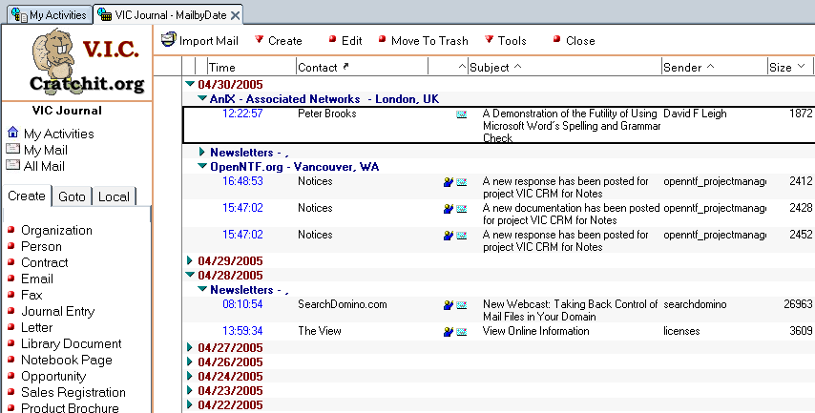Illustration 1: The VIC Interface

Basic Navigation
For the most part VIC works exactly like a website with frames. Think of Notes as your browser. There are three frames in the frameset (a frameset just splits your screen into distinct areas).
In the upper-left corner is your company logo. If you haven't defined one, then the Cratchit.org logo is displayed in front of Vic the Beaver, our mascot. Mostly this is decoration, but there is a bit of useful information displayed here. VIC is actually a collection of databases that closely interact. Below the company logo you'll see the name of the current database. As you switch between VIC's functions you'll see where exactly you are in the system.
Most of the left side of the screen is taken up by the Navigation frame (sometimes referred to as the “Navigation Pane”). You'll see that this has three tabs: the Create tab, the Goto tab, and the Local tab. I bet you can guess what they do:
- The Create tab has a number of links that allow you to quickly create documents, like Emails and Journal Entries. Since the Navigation frame is almost always displayed, then creating a document is rarely more than a click away.
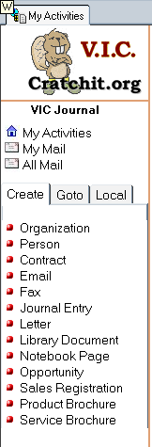Illustration 2: The Navigator
- The Goto tab lists the most important databases and views in VIC. Here's where you'd go to quickly navigate to a different section of the system.
- The Local tab displays all of the user-accessible database views in the current database. When you go to the Journal, for example, you're shown the “MyCalendar” view by default (which, unsurprisingly, shows your scheduled Journal Entries in a Calendar). You can change to other views (such as a list instead of the calendar, or a filtered view) by clicking on links in the Local tab. Again, the contents of this tab vary depending on which database you're in.
- At the top of all three of these tabs are links to a few very common features... the “My Activities” page, the view showing only your mail, and the view showing all VIC correspondence.
The bulk of the screen is taken up by the View frame. This is where all of the views and most of the forms are displayed (if a form isn't displayed here, we'll tell you why).

Database Views
A View is a list of documents that appear in a database. It might contain all of the documents in the database, but more often it's filtered to display documents of a particular type. For instance, a Mail view shows emails, faxes, and letters in the Journal. A Calendar also displays documents from the Journal, but these are scheduled activities like phone calls, meetings, and to-dos.
As you've probably surmised from the above, a Calendar is just another kind of view. You've got a few options when looking at your calendar. You can view it in several daily, weekly, or monthly formats. Calendar entries can be shown in list form as well, and if you explore the Views tab in the Navigator frame you'll find some that are available to you.
When you're looking at a list, take a moment to examine the headers. Sometimes you'll find a small icon at the right of a header. This indicates that you can change the sort order of a view by clicking on the header. A crooked arrow in this spot indicates that clicking on the header will take you to another view.
Most views are categorized. That is, the information is sorted into collapsible categories. This makes it a lot easier to find information that's repetitive. For example, a company may have many employees, but in a categorized view the company name is displayed only once. Clicking on the triangular twistie next to the company name will display all of that company's employees.
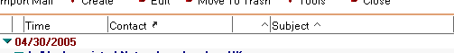Illustration 3: View Headers

The Action Bar.
Above each view (and all documents except the “My Activities” page) you'll find a series of buttons. These are action buttons and the area they appear in is the action bar. In VIC you'll find two different icons in the Action Bar... buttons that act immediately display a round 'bullet' icon next to the text. Buttons that display a menu show an inverted triangle that looks similar to the twistie you've already seen in the views.
The actual contents of the Action Bar are context-sensitive. In VIC, if it doesn't make sense to display an item, we don't. Nevertheless, just because you don't see an option in the Action Bar that doesn't necessarily mean it's not available. VIC only displays the most commonly used actions here. Familiarize yourself with the Notes Actions menu to see what other actions you have available to you. By the way, you can press [F1] to display Lotus® Notes Help at any time. This will answer most of your navigation questions.
Illustration 4: Action Bar

Forms and Documents
For the most part, forms act exactly like web pages, except that they can also include tabs. We use tabs quite a lot in VIC to keep you from scrolling through interminably long screens (that's one of our pet peeves with web-based programs). You won't find any surprises here.
As with the action bar, information is only displayed if it makes sense to display it. So if you're filling in a general Library document you won't find any vendor information. But change that Library document to a Product brochure and the Vendor and Pricing tab will magically appear.
In Notes (and therefore in VIC) there's a subtle difference between a 'document' and a 'form'. A form is something that describes how a document should look. A document is the data on the form. Sounds academic, doesn't it? So why should it matter? It matters because it reveals some of the power of Notes. There's no real difference between one kind of document and another. The data on an email and a calendar entry are largely the same. They both have a date, a subject, and some body text. It's the form that determines the difference in how the data are treated. This means that you can send any Notes document to anybody as an email, even if they don't have VIC! It also means that VIC can convert any incoming email into a Journal Entry for you! So you can receive an email through the Internet that proposes a meeting and includes an agenda, and with a mouse click you can place that meeting in VIC's calendar, including the agenda you received! No retyping, no cut-and-paste!
In this Users Guide we might sometimes use “document” and “form” interchangeably, but when we want it clear that we're talking about a full representation of the displayed document we'll say “form,” since the objects in a view are “documents” as well.

The Search Bar
This is a Notes feature that's so useful in VIC that we're going to describe it separately here even though it's in Notes' Help. Whenever a View is displayed you can display a Search Bar above the View. Click on the View menu, then click Search This View. The Search Bar will appear between the Action Bar and the View. You can type in the information you're searching for and the view will be filtered to show only the records you're looking for. So if you wanted to find everyone named “Dave” or “David” you'd just type in “Dav”. This works similarly to the Find utility in Windows.
So far that's pretty useful. But it gets better. At the lower-right of the Search Bar there's the word “More”. If you click on that then you'll either get really nice extended search functions or a message telling you that you haven't indexed the database yet. Just click on the words “Not Indexed” to display the indexing options. Go ahead and create a full-text index and include attachments. This is so easy we'll just let the screen tell you how. When the index is completed then you'll get these very nice search options.
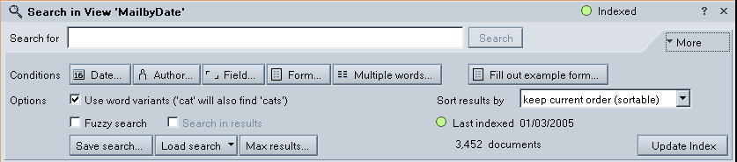Illustration 5: The Search Bar, with "More" extended
Press [F1] and Notes will tell you how to use them. With these you can do a Query-by-Example, you can search in specific fields, and you can even perform fuzzy searches that will return near misses... nice if your spelling needs work!

VIC is a collection of Databases
As mentioned previously, VIC isn't a single Notes database. Rather, it's a collection of databases that work together. Although the average user doesn't have to know this, it certainly helps if you're going to be the one setting things up. Here are a list of the databases and what you'll find in each.
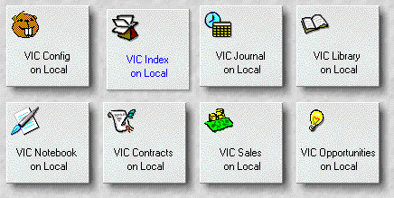Illustration 6: VIC databases on the Notes Workspace


Organizations
The VIC Index contains all of the People you do business with and the companies they work for. That's basically it. Of course, all of these people and companies are interconnected in various ways. People work for companies, which may be subsidiaries of other companies, and so on. There's no practical limit to the depth to which you can nest 'parent' and 'child' companies.


Journal
The Journal contains correspondence, in the broadest sense of the word. It documents any interaction between you and your customers. This includes printed correspondence like emails, faxes, and letters. It also includes verbal exchanges, like phone calls, meetings, conferences, and product demos.
All interaction is dated. There really is no difference, fundamentally, between any of the various types of interaction listed above. So a “Journal Entry” is properly any kind of document stored in the Journal.
In practice printed and “verbal exchanges are treated as if they were two separate collections of documents. We refer to the printed exchanges as correspondence and the verbal exchanges as journal entries, but that's pretty much a convention to keep the views from being too cluttered. You'll find that there are Views that enable you to list all of the exchanges between you and your customers on one screen.


Library
The Library contains static information... that is, information that doesn't change rapidly, and is often referred to. Think how you use a real Library, with its collection of books.
In a real library there are sections, and you may have various types of media. The same is true of this electronic Library. Here we have four major sections: Library Documents, Templates, Product Catalog, and Service Catalog
We'll explain more about these various sections and their purposes in Chapter 7: Working with Library Documents.


Contracts
The Contracts database is a place for you to maintain contract and warranty information. Although it was specifically designed to document contract negotiations, it works well to track warranties, guarantees, service contracts, and service level agreements.

Sales and Opportunities


These databases are reserved for future use. When implemented, the Opportunities database will enable the use of sales methodologies, and the Sales database will store a record of product/service sales to your customers.

Configuration
The configuration database is central place to set up all of your customizable information. Most of your drop-down lists are maintained here, as are your User Preferences. Some very technically specific information is included here as well.

The Notes Mail Database
We continue to use your Notes Mail database, even though it's technically possible (and not at all difficult) to make VIC a “mail-in” database. There are a couple of reasons for this.
First of all, collaboration aside, if we received all mail directly into VIC, you would have a hard time telling who it was intended for. This is not to mention potentially embarrassing. Best to receive your personally addressed mail into your personal mailbox first. Then you can determine whether it needs to be shared.
Second, spam is a growing problem... one with which you don't want to clutter your company database. So we avoid spam by filtering it through your personal mailbox. The only emails that make their way into VIC are those that you've told VIC to import.
That said, we make moving your Notes mail over to VIC simple, simple, simple. We'll tell you all about it in “Working with Correspondence”, later.

The Notebook
This is VIC's name for a Personal Journal. Notes comes with a Journal template, which is nothing more than a collection of blank pages on which you can put anything you like. You can categorize and title these pages as well. We've integrated this with VIC because generally we've found that sometimes you just can't beat a plain old blank page for quickly jotting down thoughts that you'll organize later, and that's what the Notebook is for.

Chapter 3: The “My Activities” Page
Depending on how you chose to set up VIC you may see the “My Activities” page when you first start Notes. “My Activities” shows the standard VIC navigation pane at the left. In addition you've got several large icons that take you to commonly used VIC features.
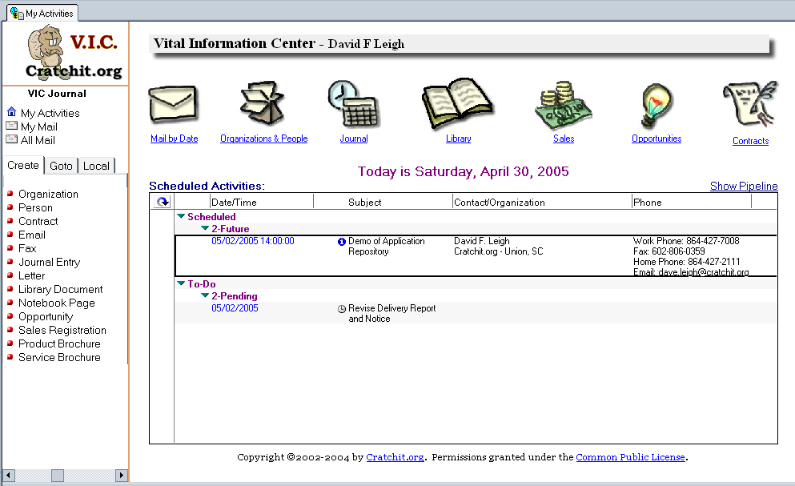Illustration 7: The My Activities Page
The bulk of “My Activities” is a view of your scheduled activities for the day. Completed items do not appear on this list, nor do missed appointments (these are appointments that have past dates but have not been marked as complete.) You can open any appointment or To-Do by simply double-clicking it on this list.
Similarly, double-clicking the icons at the top of the page will take you to the default view of the indicated database. That is, except for the first icon (the envelope)... this one is configurable. In your Personal Preferences document you can choose to link this to your Lotus® Notes Inbox or your choice of VIC correspondence views.

Chapter 4: Working with the VIC Index
Organizations and People are the basic units of information in the VIC Index. 'Index' doesn't sound like much, but it's a bit like an addressbook, a bit like a Rolodex®, and something like a file folder, but faster and more informative than any of the above.
VIC's Index is where you keep information on all of the Organizations and People you interact with. This includes customers and clients, vendors, business partners, trade organizations and fraternities.
By the way, a word about terminology. Sometimes you'll see people referred to as 'contacts,' 'customers,' or 'clients.' Don't worry about it... these all mean the same thing to VIC. The only difference is in how you interact with them. Similarly, the documents that describe people and organizations may be referred to as 'profiles' or 'records.' These are just different ways of referring to the same thing.

Organizations
VIC was built with person-to-person interaction in mind. So we look upon an organization as a way to relate or group people. Earlier I mentioned that, while you may do business with a company, it's the people in that company that are going to make or break your business relationship. And VIC is all about improving your customer relationships. So if you have thought up to now that you do business with organizations, we invite you to modify your thinking just a bit.
The purpose of an organization is to define a group of people who work together. This is a handy definition, because we can use it to extend the capabilities of our program.
“Extend the capabilities of a program just by defining a term?” you may ask. Sure. Our definition of an organization includes customers and clients, vendors, business partners, trade organizations and fraternities. Not only that, but we can use it to define subsidiaries of a corporation, or departments within a company. All these can come together into an organization.
This makes things quite handy for us. Rather than being locked into a situation where an organization document defines a 'company' we use it as a reference to group any arbitrarily defined group of people. For instance, it can be useful to create an Organization called 'Mailing Lists' or 'Newsletters' under which email newsletters are automatically filed.
Illustration 8: Corporate Hierarchies
The Index also allows you to organize these groups in hierarchies, as shown in Illustration 8.
Note that every organization can have people associated with it, and can also have other organizations associated with it. In this case we'd refer to the top-level organization as the Parent and its subsidiaries as children. There is no limit to the depth you can nest children.

Creating an Organization Profile.
To create an organization, click “Organization” on the Create tab of the Navigator pane. You'll be presented with a blank Organization document. Just fill in the obvious information on the General Information tab... name, address. The Account Information fields have hotspots associated with them. Account Type and Account Status were defined in the Configuration database when you set up VIC. If this new organization is a subsidiary of another you can select the the parent using the appropriate hotspot.
There are a couple of other fields that are worth mentioning here. Look below the name, near the top of the page. Each organization is automatically assigned a UniqueID by VIC, but you have the option of entering a couple of other ID numbers. The Client Number is designed to accommodate an ID number that you may have assigned this organization in other software, such as an accounting package. It can facilitate automatic importation of information from your accounting software into VIC. The Federal ID field is used for vendors and financial institutions (banks or credit unions) to link this document to reports on the FDIC website. You can also use the Federal ID field to accommodate vendor reseller IDs.
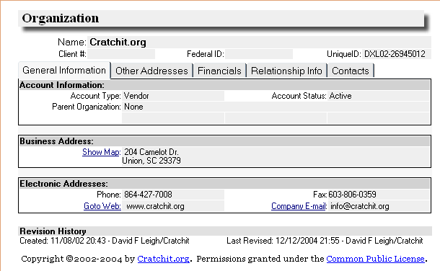Illustration 9: An Organization Document
Actually, at this point your organization has been defined and you can go ahead and save the document. However, you will notice that there are a number of other tabs where you can place additional information.
On the Other Addressses tab you can enter shipping, mailing, and billing addresses if those differ from the street address you've already entered.
On the Financials tab you can enter information about your financial relationship with this organization. The actual fields that appear here differ depending on whether this organization is a client (customer), vendor, or a financial institution. You might want to customize VIC to pull this information automatically from your accounting software. If the organization is a financial institutions you'll also see a hotspot here that will take you directly to the FDIC website.
The Relationship Info tab allows you to assign this organization to one or more categories that you defined during setup. You can also type in your own categories ad hoc... just type them in and separate them with commas. Also, there's a RichText Notes field where you can type in any information you like. You can also insert attachments or embed documents here. Just use the Attach button on the Action Bar.
Finally, the Contacts tab shows all of the people that are associated with this organization. At the moment this will be blank, as you haven't created any. (We'll show you how to do that after you've saved this document.) Also you'll that you can assign names to the Lead Professional field and Team fields under this tab. If your name appears in either of these fields then this organization will appear in your “My Organizations” view. Go ahead and click 'Save and Close' on the Action Bar.

Organization Views
Of course, Now you'll want to see that your organization has been saved. Click on the Navigator's Goto tab and click Organizations. A list of organizations will appear. Your new organization appears in the list.
There are other views available to you. Click on the Navigator's Local tab to see a list of them. If this is the only organization you've entered then clicking on these might not show much difference, but they can be quite useful in seeing different 'cuts' of the data. Explore!

People
People are the focus of customer relationships. So Person profiles are the primary focus of the VIC Index.
So now that we've created an organization, let's assign some people to it There are a couple of ways of doing this. We'll do it the hard way first, then the easy way.
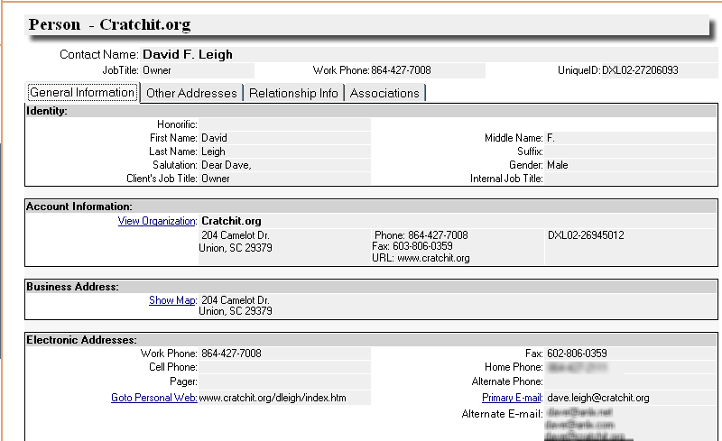Illustration 10: A Person document

Creating a Person Profile – The Hard Way.
Click on Person in the Navigator's Create tab. Fill in the blanks. Click 'Save and Close' on the Action Bar. Done.
Wait. That didn't seem so hard! Well I call it “the hard way” because you'll have to click on the Select Organization hotspot and select the Person's organization from the list. Although this will fill in the Account Information fields for you you'll have to fill in the Business Address and Electronic Addresses yourself.
The other tabs are similar to what you'd find on the Organization Profile, with the addition of Birthday and Spouse fields under the Relationship Info tab.
Go ahead and look at the Views again. You'll see that the new person appears in the list directly underneath the organization profile.

Creating a Person Profile – The Easy Way.
OK, what could be easier than what we've already done? Well, highlight the Organization profile in the view you've got displayed. Now, on the Action Bar click Create, then Person.
A new Person Profile will be displayed, but this time it's not entirely blank. The account information is already filled in, as are the Business Address fields! These were pulled from the highlighted Organization Profile... all you have to do is enter the information that's unique to this person!
By the way, this doesn't just work in a view. It also works when you've got the Organization profile open, or if you've opened the profile of a person that belongs to the same organization, as well as if you've got another person highlighted in a view.
This is the major difference between the Create menu on the Action Bar and that on the Navigator. If you use the Navigator you'll get a completely new, blank profile. If you use Create on the Action Bar VIC will inherit what information it can from the currently selected document.
Look in the Organization views and again, you'll see the new person listed.

Chapter 5: Working with Journal Entries
Most of what you do in VIC involves the Journal. This is where all of your scheduled activities, emails, letters, and faxes are stored. Needless to say, if you use VIC regularly (as you should) then the Journal will grow to a very large size. Not to matter, Notes can handle a large database as easily as it can a small one.
There are basically only two different kinds of information stored in the Journal: scheduled activities and correspondence. Correspondence includes emails and faxes, and though they're also stored in the Journal, we'll discuss them separately in the next chapter. Here we're primarily concerned with scheduled activities, which we'll generically refer to as Journal Entries.

Types of Journal Entries
Although there seem to be a large number of different types of Journal Entries, they're all basically variations of the same thing. Journal Entries are those types of documents that are appropriate for inclusion in a calendar. Let's quickly discuss the defining characteristics of the various kinds of Journal Entries before we talk about how to create them.

Phone Calls
This is the default Journal Entry type, mainly because this is what we expect you'll be doing most often. So VIC is designed to make creating record of a phone call easy enough to do while you're actually talking on the phone. You can also schedule phone calls in advance. In views you'll see Phone Calls identified by an icon of a little yellow telephone.

Meetings
Meetings are just like phone calls. The difference in type is simply for your convenience, so you know that you (or the client) have to appear in person. In views Meetings are identified by an icon of a handshake.

Conferences
Phone Calls and Meetings are between you and some other person. Even when a meeting involves more than one person you'll typically associate it with a single primary contact.
On the other hand, Conferences are a special type of Journal Entry that allow you to schedule a meeting between you and people belonging to several other organizations. Although this is probably infrequently used, when it is it's indispensable. A good example of a conference is a product training session or some other type of class.

In views, Conferences are identified by an icon of a group of people (it looks a bit like a blue and purple blob, but take my word for it... it's people). Instead of the contact being listed in the view you'll see the word “[MULTIPLE]”.

Service Calls
Service Calls are basically just meetings. Like Phone Calls, the difference is purely conventional, so that you can plainly identify them in a view. Because Service Calls involve on-site travel, Service Calls are identified by an icon of an automobile.

Product Demos
Product Demos are another special type of Meeting. Keep in mind that VIC accommodates the needs of consultancies. This is a way of scheduling you, a client, and a vendor at the same meeting, while also identifying the product that's to be demonstrated. Don't let the Vendor bother you... the 'vendor' can just as easily be you.
In views, Product Demos are identified by a blue 'information' icon.

Trade Shows
Trade Shows, like Service Calls, are basically just meetings. However, a Trade Show can span multiple dates, so it has a start date and an end date.
In views, Trade Shows are identified by a globe icon.

To-Dos
To-dos are special cases. Although they're basically similar to meetings, trade shows, and phone calls, they (usually) aren't associated with a client, and they're separated in the views. To-dos have a bit more complicated schedule and status than is usual for other scheduled activities. While most Journal Entries display the status field, this is really only done for two reasons. First, so that you can drop a scheduled item from the “My Activities” page by changing its status to 'Complete'; and second, so you have some way of identifying missed appointments (these are past-due meetings with a status other than 'Complete')
To-dos use the status field more completely, and this is reflected in the views as well. The reason for these different statuses is simply to help you identify the current state of the various tasks you have scheduled. You can use this information to help you manage various projects you may be working on.
Also, unlike other scheduled activities, To-dos have scheduled start and end dates, but no start and end times.
  - Pending To-dos are those that are scheduled either today or in the future. They're identified by the icon of a clock face (same as in the Lotus® Notes calendar).
  - In-Work To-dos are identified by the icon of a green traffic light. In-Work To-dos are never marked overdue.
  - Suspended To-dos are identified by the icon of a red traffic light. This status denotes items that you've set aside or abandoned for some reason, but don't want to mark as complete. Suspended To-dos are never marked overdue.
  - Complete To-dos are identified by the icon of a green check mark. These do not appear in your “My Activities” page, but they do appear in the calendar views.
  - Overdue To-dos are identified by the icon of a red exclamation point. These always appear at the top of the current date, no matter when they were scheduled. You don't manually mark To-dos as overdue... this will be done for you, automatically, by a scheduled agent.

Documenting a Phone Call
What a lot of Journal Entry types! They must be difficult to create, right? Not at all! VIC was designed to get you into creating a Journal Entry very quickly. Remember that all these 'different types' of Journal Entries are just variations on the theme of 'scheduled activities.' So they're all created the same way.
To do it, click “Journal Entry” on the Create tab of the Navigator. This will open a new, blank Phone Call document. If you're documenting a phone call (likely), then you're in business. Otherwise, click on the Type hotspot and select the desired type.
Of course you'll want to record the activity. The default start time is now, and the default end time is fifteen minutes from now. This is so you don't have to do anything to start documenting a phone call. Just start typing in the Notes field. When you've hung up the phone click the Now hotspot next to the End Time field to record the current time. Then click on the Account tab, then the Select Contact hotspot, and associate this with the person you've just been talking to.
Before we move on, let's look at the other tabs. What kind of information can we associate with this Journal Entry?
  - Dates/Status: As we've seen, Phone Calls have a single date, a start time, and an end time. There's also a status field: changing this to 'Complete' will drop the Phone Call from the “My Activities” page.
  - Account: This works exactly like the Account Information fields in any of VIC's documents. Click on the Select Contact hotspot to pick a person from the list.
  - Categories: Fields on this tab allow you to categorize the document, purely for your own filing purposes. You can either type into the fields directly or use the hotspots to select categories from keyword lists you've previously defined in the configuration database.
  - Expenses: All Journal Entries potentially have expenses associated with them, be they phone charges, travel expenses, materials, or fees of some sort. The Expenses tab provides a place to record the overall reimbursible expenses and to attach a detailed expense report. Using the Expenses view it's possible to set up your business processes so that you no longer have to separately submit expenses.
  - Associations: If your name appears in either of the fields in this tab (Lead Professional or Team) then the document will appear in your personal Journal views (including “My Calendar”).
Now let's look at what happens when we create other types of Journal Entries.

Creating Other Journal Entries
In every case, a Journal Entry is created exactly like a Phone Call. Once the document is created, you can change the Journal Entry type by clicking on the Type hotspot and selecting a new type from the pop-up list.

Meeting or Service Call
A meeting or service call is documented exactly like a phone call. The only difference is the contents of the Type field, and that's just for your information and convenience.

Trade Show
A trade show is like a meeting, except that it has both a start and an end date. Typically, with a trade show you'll use your primary contact at the trade show organization in the Account tab. You'll probably want to carefully document your trade show expenses in the Expense tab so you can be reimbursed as well.

Conference
When you change the Type field to 'Conference' then you'll see a new tab appear: Conference Attendees. Click on the Add Attendees hotspot to select people from the pop-up list. You can select multiple attendees by clicking on the blank column next to the desired names. Check marks will appear next to the names. Click 'OK' and the list of attendees will be filled with the names you've selected. Other than that, a conference is just another meeting.

Product Demo
When you change the Type field to 'Conference' then you'll see a new tab appear: Vendor and Product. You can click on the Select Contact hotspot to select from a list of vendors (note that the list contains only vendors, as defined by the Account Type field in the organization profiles). You can also select a product from the list of products in the Products Catalog of the Library, or you can simply type in the name of a product.

To-do
Changing the Type field to 'To-do' will change the contents of the Dates/Status tab. The time fields will disappear and an Completion Date field will appear.

Journal Database Views
The Journal provides numerous views of your documents, both in list and calendar format. While on the “My Activities” page, look at the Views tab on the Navigator. Note that there are three folders into which the views are divided: 'My Documents,' 'All Journal Entries,' and 'All Mail.' The difference is that the views in the 'My Documents' folders contain only those documents where you are the Lead Professional or are a Team Member.
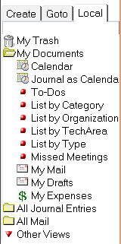Illustration 11: Journal Views
You'll note that you can view the Journal Entries in a Calendar or in any of several list formats. Although the Calendar looks like a single view, there are actually many options for viewing it. You can see your documents in a monthly, weekly, or daily format that may optionally exclude weekends.
In addition to the Calendar view, you can list your To-dos by status; you can list all scheduled activities by organization, or can list them by type. In each of the list views you can change the sort order by clicking on the column headers.

We'll look at the correspondence (mail) views in the next chapter.

Chapter 6: Working with Correspondence
We refer to all email, printed letters, and faxes collectively as correspondence. Correspondence is stored in the Journal along with the Journal Entries, but are separated into different views for retrieval. Whereas Journal Entries represent personal interaction between between you and your business associates, correspondence represent printed interaction (that it may be electronically “printed” rather than on paper is unimportant).
For small businesses, keeping track of correspondence has always been a somewhat haphazard affair. Email is generally kept in a program of its own. In almost every mail program, Lotus® Notes and Microsoft® Outlook included, incoming emails may be separated into folders, but outgoing emails are often just jumbled together in one 'Sent' folder. Incoming letters are usually kept in manila folders in a file cabinet, but outgoing letters might be stored loosely in folders in your computer. Bringing all of this information together to form a coherent record of your interaction with business partners can be a frustrating, time-consuming, and error-prone affair. Most often, it simply doesn't get done.
VIC improves this process immensely. All correspondence, printed or electronic, are stored in the Journal. You can look in a 'Mail' view and see all of your “printed” correspondence with a customer... no asking the secretary, no visiting the file cabinets. Furthermore, you can look up this information at any computer with access to VIC, even over the Internet. Also, you're not constrained from referencing this information because someone else has the customer's file. Real-time sharing of information: what a difference!
Also, any outgoing letters, faxes, and emails, and any incoming emails are automatically filed for you! The very act of addressing your correspondence ensures that it will be filed properly without any further effort on your part.

Email
Lotus® Notes is an email client. So the obvious question is, “what does VIC give me that Notes alone doesn't?” The answers are collaboration, consistency, coherence, and convenience. Although Notes alone does handle email, it doesn't categorize them for you. It doesn't file them for you. And it doesn't store your professional email together with your colleagues' so you can see all correspondence with your business partners as a unit. And it doesn't store your email together with your printed correspondence.
VIC does all of that. At the same time, VIC retains the features of Notes unmodified so that you can operate without fear of being locked out of upgrades, and so that your Lotus® Notes mail template works precisely as described in the Notes documentation.
Let's see how it works.

Sending
Creating an email using VIC is just the same as creating any other VIC document. On the Navigator's Create tab click Email. You'll be presented with a blank document. Simply click the Select Contact hotspot to address the email, fill in the body of the message, and click Send on the Action Bar. If you want to send the message to more than one addressee, click Address and select the additional addressees.
As usual, you can categorize your document and assign it to other team members. VIC also provides a very handy feature not found in Notes. You can annotate your emails using the Comments tab. Comments entered here do not get sent to the recipients, so they're very nice for recording personal thoughts associated with this message and communicating them to your teammates.
Sent mails are retained in VIC's Journal, but are not placed in your Notes mail database. Unlike the Notes mail database, VIC does not have a 'Sent' folder. Instead, your emails are automatically filed for you. Using the various available views, you can display the mail grouped by organization, or by contact, email address, sender, and so forth. Sent and received correspondence are shown together so you can more easily follow the thread of a 'conversation.'

Receiving
Receiving emails is a little bit different, and as usual there's a good reason for it. If you want to receive mail that's addressed to you personally, Lotus® Domino (Notes' mail server) needs to have access to a database that belongs to you alone. VIC is designed to be shared, so although it's possible to make it a mail-in database, you wouldn't know who specifically received mail was intended for. As a result we filter all incoming mail through your Lotus® Notes Inbox.

Interacting with the Notes Inbox.
Filtering our mail though the Notes Inbox gives us a couple of benefits other than those I've mentioned. One is that your personal mail is kept entirely personal. Notes does allow you to allow others access to your mail file, but it's inconvenient. Among other things, you can only look at one Notes mail file at a time; all your teammates would have to provide you with access; and different people organize their emails in different ways. VIC improves this by letting you all share documents consistently and in one spot.
A second advantage is that your Inbox insulates VIC from spam. We all hate it, but it's a fact of life. Better that it not wind up in your professional files.

Transferring mail to VIC
Of course, the fact that we filter mail through Notes raises the question of how we move the incoming mail from our Inbox into VIC. Fortunately we've made that simple, and have done so without modifying your Notes mail template. There are two major methods of doing this, and of course you can select your own preference in your Personal Preferences document.

Importing from the Lotus® Notes Inbox
For the ultimate in convenience, have VIC scan your Inbox for incoming mail. Simply edit your Personal Preferences document. In the Email tab, in the Import Options subtab, select the Import Mail from Inbox radio button. Using the Remove spam from Inbox? radio button you can optionally set up a folder to which non-matched mail will be removed. Don't worry, this will become clear in a moment.
Now, whenever you want to import your business mail to VIC just open a correspondence view in VIC and click on the “Import Mail” button in the action bar. That's it. No searching no dragging, no manual sorting. Instead, VIC will compare the email addresses of incoming mail with the email addresses in your Index. If it finds a match, then it will move the mail to the Journal and automatically associate it with the proper contact. If you want it any easier, then VIC will even automatically import mail on a schedule, and you can even skip the mouse click.
If you've set Remove spam from Inbox? to 'Yes' and specified a folder when you set up your Personal Preferences then all of the non-matched mail will be moved to that folder in your Lotus Notes mail database. This keeps your Inbox clear so that processing is done quickly. If you use VIC extensively, as I do, you'll soon appreciate the fact that your important correspondence is brought to your attention first, and anything else is held in the spam folder to be sorted through when you feel like it. Note that VIC simply moves the mail; it doesn't delete it from the Notes Inbox.
Of course, you'll want to have some way of allowing important mail to come through even if the senders' email address isn't on file. In your Personal Preferences document you can include a list of keywords. If any of these keywords appear in the subject of an email, then VIC will import the mail and file it as “->Imported - To Be Filed”.

Setting up and using a VIC transfer folder
Perhaps you want a bit more manual control over what gets sent to VIC.
  - Create a folder in your Notes Inbox by pulling down the Create menu and clicking Folder. You can name it whatever you want, but I'd recommend simply, “VIC”.
  - Edit your Personal Preference. Select the “Custom Folder” radio button and enter “VIC” in the text field next to it (or enter the name you chose, if different)
Congratulations, you've set up your transfer folder. You won't have to do that again. Now to use it.
You'll read your incoming mail in the Notes Inbox. When you see a message that you thing belongs in VIC, just drag it into the VIC folder. If you've scheduled the ImportMail agent then it will eventually be picked up from there automatically, but let's assume for a moment that you want to expedite the matter.
To import your mail manually, open your “My Activities” page. Pull down the Actions menu and click “Import Emails from Lotus® Notes”. That's it.
It'll take a moment to import the emails and file them for you. When you look in the My Mail view then you'll find the new messages already filed under the proper organizations. That is, of course, providing that the senders already exist in your VIC Index and that you've got their email addresses properly entered in the Person profiles. If not then not to worry... you'll find the mails under “-> Imported - To Be Filed” and you can manually associate them later. The important thing is that they're in VIC where they can be shared.

Shared vs. Private mail.
Some CRM systems provide a mechanism for restricting access to certain documents or making them private. In the several installations I've been involved in this feature has never been used, and has proven to be more of a hindrance than a help. We've usually had to hide it. As a result this is one feature you will not find in VIC. VIC is built for sharing. If you don't want to share a document, then don't put it in VIC. Because VIC works so well with the Inbox this is no hardship at all.
As we'll see later, VIC's lack of internal controls doesn't restrict you from using selective replication to limit what's on a laptop. The Lead Professional and Team Members fields in VIC documents designate who's responsible for a document, but they don't prevent access by others on the server.
Also, importantly, VIC's lack of internal controls doesn't equate to a lack of security. VIC databases are subject to Access Controls provided by the Domino server.

Letters and Faxes
Letters and Faxes are similar, except for some minor formatting differences. Both are designed to be printed (though a fax is printed through a fax print driver).

Creating Letters and Faxes
In the Navigator's Create tab click Letter or Fax as you prefer. A blank letter or fax will be displayed. Click on the Select Contact hotspot to associate it with an account. As with any VIC document you can categorize your correspondence.
When composing the body of your message use Rich Text formatting to select fonts and font attributes. These are available from the toolbar or by right-clicking.
Print by simply using the Print button on the Action Bar.

Sending a Fax
Faxes are sent through a fax printer, such the Microsoft® Fax built into Windows. eFax Messenger is a good choice, as it will expand and print attachments. In a future release we'll have VIC automatically set the fax number, but at the moment you'll have to type that in yourself. Fortunately VIC displays the fax number in the Account tab, so you don't have to look it up.

Mass Mailings and Faxes
We don't recommend using VIC to actually send mass faxes, as for marketing. We've used such solutions with other products and the result has never been satisfactory. As such, we don't even bother to pay lip service to it in VIC. We do have some recommendations, though.
For mass faxes we recommend using a service such as Xpedite provide. Xpedite allow you to create an email from a Microsoft® Word document and an address list provided in .CSV format. With their resources they can deliver bulk emails in a fraction of the time at a fraction of the cost that you can using a single phone line.
For bulk postal mailings we recommend simply using your word processor to generate a mail merge document, or using a reporting tool such as Cybernet Software Systems' IntelliPrint. Then, “for the record,” save the document and the .CSV file as attachments in a VIC document.
You can use Notes' File|Export facility to generate the CSV files for mail merge or mass faxing from a data view. Alternatively, you can mail merge by directly connecting your word processor to VIC using ODBC. Keep in mind, though, that you lose the record of the recipients this way... we recommend the .CSV export.

Importing received Letters and Faxes
Of course, you can also import the letters and faxes you receive. To do so you'll need a scanner or you'll need to be able receive your faxes electronically.

Scanning
Your scanner software needs to be OLE ready. We've tested with Visioneer scanners and software with great success.
- Create a new Letter. Click the Inbound checkbox. (you don't have to but it's useful for identifying scanned letters in the views.) Be sure to associate the Letter with the sender.
- Put your cursor in the message body.
- Pull down the Create menu
- Select Object
- Select Image Document from the list. A list of input sources will pop up. If you have more than one input device you may be asked to select from them.
- Your scanned letter will be inserted into the VIC document. Click Save on the Action Bar.

Importing
Most fax software can save your faxes as TIFF files. Notes can import these handily.
- Create a new Letter. Click the Inbound checkbox. (you don't have to but it's useful for identifying scanned letters in the views.) Be sure to associate the Letter with the sender.
- Put your cursor in the message body.
- Pull down the Create menu
- Select Picture
- Locate the received fax and click Import
- Your scanned letter will be inserted into the VIC document. Click Save on the Action Bar.

Drafts
Emails, Letters, and Faxes can be saved as Drafts. In this case they're not sent, but appear in the Drafts view. This allows you to quickly locate them so they can be edited and sent later.

Correspondence Views
There are a number of views (identified as “Mail” views) showing correspondence. While in the Journal you can explore these by clicking on the Local tab of the Navigator. The different types of correspondence are identified as follows:
  - Letters are identified by a white envelope icon.
  - Emails are identified by a blue envelope icon.
  - Faxes are identified by a red envelope icon.
  - Additionally, incoming correspondence is identified with the icon of a waving man.
  - Emails containing attachments are further identified with a paperclip icon. These are MIME attachments, so embedded objects and pictures are not counted as attachments.

Chapter 7: Working with Library Documents
The Library contains 'static' information... that is, information that doesn't change rapidly, and is often referred to. Think how you use a real library, with its collection of books.
In a real library there are sections, and you may have various types of media. The same is true of this electronic library. Here we have four major sections:
- Library Documents
- Templates
- Product Catalog
- Service Catalog
Library Documents is the General section of this database, not reserved for any particular purpose. You can store anything you like here and categorize it in any way you like. The Views will automatically reflect the categories you define. Common uses for this section are for company news bulletins, competitive intelligence, procedures and guidelines, and so on.
The Templates section contains documents that you would commonly embed in other documents. Here's an example: You're writing a letter to a new customer thanking him for his business. This is a common activity, so to save time you may create some boilerplate text that you can insert into the letter you're writing. Since VIC also addresses the letter for you, there's very little work involved in providing your customers with that “little extra” service.
Another example: All Journal Entries have an Expenses tab. For convenience you might want to work up your expenses using a Microsoft® Excel or OpenOffice.org spreadsheet. No problem: just embed your spreadsheet in a Library document and you can insert it into the Expenses tab with just a few clicks. This way you don't have to go to the trouble of managing a bunch of loose worksheets and trying to collect them into expense reports. With VIC the expense reports are tightly bound to the activities that caused the expense, and accounting can retrieve the expenses directly from the system! No more submitting expense reports!
There are also two catalogs in the Library. Now I can tell you how they were intended to be used, but you can use them as you like. VIC was written to accommodate businesses that do consulting services. Often this type of business does not associate itself with a product, and prefers to keep its internal services separate from the vendor products that they might recommend or evaluate on behalf of their customers. So we provide the ability to have two catalogs, though you may not choose to use them both.

Library Categories
These are determined by you for your own use, and are defined in the configuration database. We provide some defaults, but ultimately you determine how to organize own library. A Library document can belong to more than one category. In this event, the document appears under both categories in the categorized Library views.

Products Catalog
The Products catalog is intended to keep product brochures from third-party vendors. We call these documents “Brochures” because we find that the “catalog/brochure” metaphor helps keep people straight regarding their purpose. It will come in handy later to differentiate the product description from a product “as sold” when we add a Product Registry in a later release.
You can include product descriptions and pricing in a Product brochure. You can also use the “Document Content” field to store real brochures from the vendor, either as Web links, PDF documents, or scanned documents.

Service Catalog
The Services catalog is intended to keep brochures for the various services that your consulting company offers. As such, the Services vendor is always your company. You might choose to disregard this entirely and simply use the Products catalog for both internal and external products. To do this you'd simply list your own company in the VIC Index as a vendor.
As with the Product brochures, you can include product descriptions and pricing in a Service brochure, as well as embedded or attached documentation.

Templates
The fourth major category of Library document is Templates. The body of a Template is intended to be inserted into another document. Boilerplate text is an one example. This is a standard, preformatted letter that you can send as-is or with minimal modification . An embedded spreadsheet for calculating expenses would be another example.

Library Database Views
All Library documents can be displayed by Author, Category, Subject, or Technology Area. In addition, Products and Services can be viewed by Name. Products can also be viewed by Vendor.

Chapter 8: Working with Contracts

Introduction
Keeping in mind that VIC was developed to provide support for consultancies, you'll find some interesting features in the Contracts database. For one thing, both the Client and the Vendor are user-selectable. This is because VIC supports those situations where you, as a consultant, may negotiate contracts for your clients. As a value-added service, you may wish to track these third-party contracts on behalf of your clients, and issue reminders when the contracts are due for renegotiation or expiration.

Creating Contract Documents
Creating a Contract document isn't different from creating any other VIC document. You can select Contract from the create tab of the navigator pane, or from the Create action button. You'll be presented with a blank document like the one in Illustration 12. Using the hotspots you can select the client and the Vendor. You may either select from a list of products using the Select Product hotspot or type the product name in the box.
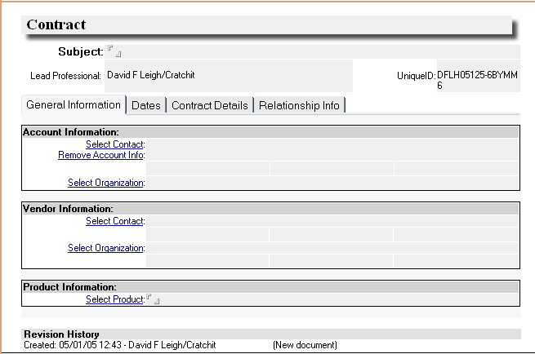Illustration 12: A new contract document
Now you'll move on to the Dates tab and enter effective dates for the contract.

Scheduling Reminders
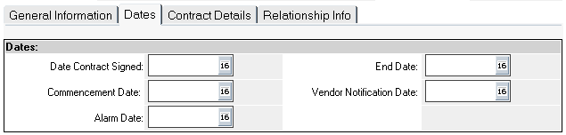Illustration 13: The Dates tab of a contract document
In the Dates tab we'll record the import dates associated with this contract. There is the Date the contract was signed, the date on which it becomes effective (the “Commencement Date”), and the date on which it expires.
There are two other important dates here... the Alarm Date is simply the date on which you'll be reminded of the contract's expiration (you'll receive an email); and the Vendor Notification Date is an optional date on which the vendor will receive a similar notification. The reminders that are sent are governed by information you've entered in the Global Profile document in the config database.
Now you'll want to record some specifics about the contract.

Contract Details
You can record the terms of the contract and specific provisions for termination or dispute resolution. The contract document itself can be stored as an attachment in the Contract Document field.
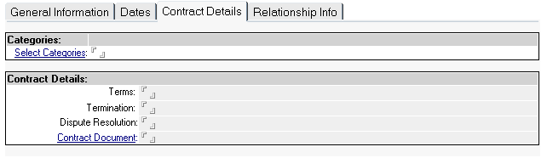Illustration 14: Contract Details
If your administrator has full-text indexed your Contracts database then you can search contracts by the actual text of the contract.

Contract Database Views
Contracts can be viewed by any of the following criteria:
- by Category
- by Client
- by Vendor
- by Lead Professional
- by Product
- by Alarm Date
- by Alarm Calendar

Chapter 9: Using VIC with Other Programs
VIC can directly embed documents using other programs that are OLE enabled. To do this you pull down the “Create” menu and select “Object.” This menu option is only available when you're in a RichText field. The body field of every VIC document allows Rich Text.
Be careful when using embedding! Make sure that all of your users can access embedded objects. Basically, this means that they'll have to have the software installed that can manipulate the object. Usually this would be the same software that created it. If you think this will be a problem then you're safer attaching files than embedding them.

Office Suites.
VIC is known to work with the following office suites:
- OpenOffice.org / StarOffice
- Microsoft® Office
- Lotus® SmartSuite.
- Corel® WordPerfect

Other Applications
By no means have we exhaustively tested VIC with other applications. Anything that works with Lotus® Notes should work here. Applications we've found useful include SmartDraw and Paintshop Pro.

Scanners
We've already discussed this in section on scanning. Basically, any scanning or camera software that can be used as an OLE server can be used successfully with VIC.

Special Print Drivers
Special print drivers are necessary to use certain VIC features, such as outbound faxing. Microsoft® Fax Service is included with Windows. It enables you to send faxes through your fax modem. eFax Messenger Plus is another good choice for this. Alternatively you can use a server-based fax service (this is recommended for a networked installation).

Enhanced Reporting Tools
Other than the included views of the data (and you can create your own),

IntelliPrint and Intelliview
We cannot recommend these highly enough. We find that these products from Cybernet Software Systems provide the very best in integration with Lotus® Notes, and they work well with VIC. These can be installed on the client and integrate directly with Notes.

Crystal Reports
Frankly, we haven't used Crystal Reports with Lotus® Notes, though we understand it works well. Here is a link to more information:
http://www.dominopower.com/issues/issue200006/crystal0600001.html

Other Reporting Tools
You can also use other tools such as Microsoft® Access, Microsoft® FoxPro, or OpenOffice.org Base to generate reports or mailing lists. To make this possible you'll have to install NotesSQL, an ODBC (Open Database Connectivity) driver for Notes and Domino. This takes a bit more work; you'll need to set up an ODBC data source and generate your own SQL queries from within the reporting tool. But if you've already got Microsoft Access or OpenOffice.org 2.0 and you're on a limited budget this might be the solution for you.

Chapter 10: Setting Up VIC.

Installing VIC
VIC can be installed in either a single-user or a multi-user configuration. In the single-user configuration all that's needed is the Lotus® Notes client. For a multi-user configuration you should install VIC to a Domino server, which is then accessed by the clients. At this time there is no setup program, so installation should be done by a qualified Domino administrator. If any of this is Greek to you, don't worry about it. Your dealer will do the installation. That's what he's there for.
For a minimal single user installation:
- Copy the VIC databases to a directory under your Lotus\Notes\Data directory. Typically this is Lotus\Notes\Data\VIC.
- Open the VIC Configuration database (vic_config.nsf). Do not simply bookmark the database. Then, in the Local tab of the Navigator, click Global Profile,
- make sure that the database locations are the same as the place where you've installed.
- Fill in the information in the Contracts Options tab.
- In the Local tab of the Navigator, click System Variables, then make sure that the system variables contain information that's appropriate to your company.
- In the Local tab of the Navigator, click Keywords, then make sure that the keyword lists are appropriate to your company.
- In the Local tab of the Navigator, click User Preferences.
  - Make sure that the default profile contains information appropriate to your company.
  - Compose a new user profile and make sure that the information is appropriate to you personally.
- In the Navigator, click “My Activities”. Then click any whitespace on the My Activities form. Right-click on the “My Activities” tab and select Create Bookmark. Create the bookmark on the Bookmark Bar, so it's always available when you're in Notes.
- Right-click on the bookmark you've just created and select Set Bookmark as Home Page. Close and reopen Notes. The “My Activities” page should be automatically displayed.
- Finally, if you wish to use the VIC Index as a Notes NAB, open the File menu, then Preferences, then User Preferences. Click Mail. Click the Browse button next to Local Address Books field, and select vic_index.nsf.
For a server setup, the databases are copied under the Data directory of the Domino server. Then, after you've set up your Access Controls you'll set up each client as described above. If you're going to use vic_index.nsf as a NAB then you should create a local replica of vic_index.nsf on the client. If the client will be working off-line (on a laptop or home office) then all of the databases should be replicated. Also, if you're using an underpowered server you should probably replicate to all clients to improve performance.

Creating Configuration Documents
Configuration documents provide a method whereby you can customize VIC without having to modify the program itself. Simply edit the documents and you'll see the changes reflected in the program.
Configuration documents are stored in the VIC configuration database.

Global Profile
The Global Profile contains those variables that apply to all databases equally.
Technically, though you edit the Global Profile in the Configuration database, it's then automatically copied to all of the other installed databases. Illustration 15 Shows the options for setting up your library paths; Illustration 16 shows the Contract options.
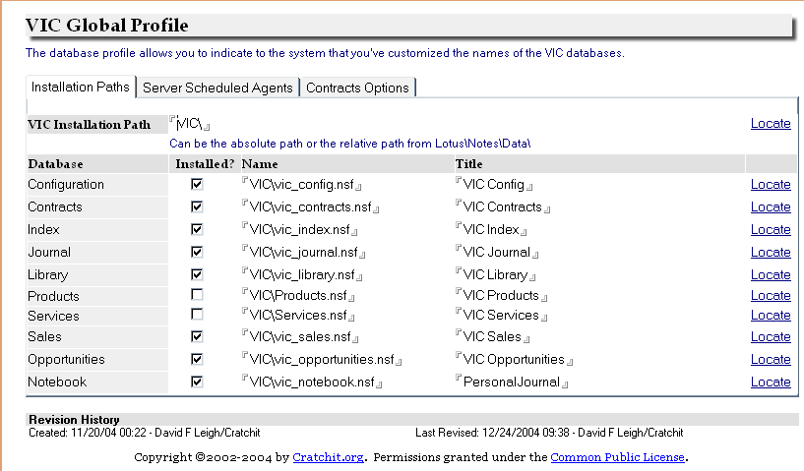Illustration 15: Global Profile: Installation Paths

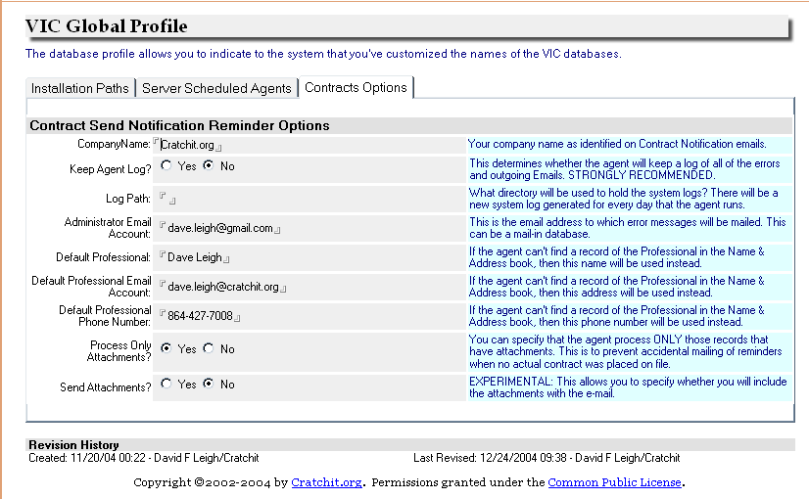Illustration 16: Global Profile: Contract Notification Options
In the Contract Options tab you determine the specific workings of how you're reminded of expired contracts and contracts due for re-negotiation. Since this is largely self-explanatory, we'll move on.

Keywords
Keywords are used in picklists. In most cases where you're provided with a choice (such as Job Titles) VIC looks to the configuration database to provide your list of choices. Each of these lists is identified by a name, or “keyword”.
All of the keyword documents you'll need for VIC are predefined in the configuration database. All you'll need to do is edit them. When editing your lists, simply enter each list item on a separate line. Before saving the list you may choose to sort it. Just click the “sort” hotspot.

System Variables
While Keywords provide a list of values from which you'll choose as the program is running, System Variables provide single values that the program itself uses. For instance, when running on the server, VIC needs to know whether to write logs, and if so, where to write them. It certainly can't stop and ask you, so gets this sort of information from System Variable documents.
VIC comes with all the System Variable documents it needs, and each document contains a description of its use. You simply will need to edit them to make VIC behave as you like.

Field Maps
You should not have to edit these at all. In fact you shouldn't even attempt it unless you're very familiar with the way VIC operates internally. The purpose of field maps is primarily to determine the way that synchronization works.
Synchronization is the process that keeps all of the data in VIC consistent. For example, when you change a person's address you want that change to show up in the Journal Entries you've created for that person. Field Maps tell VIC which fields you want to update.

Letterheads
When you create letters and faxes, the letterhead is pulled from your User Profile (which we'll discuss next). Although each user could create his own letterheads from scratch, it's useful to define one or more standard letterheads that your users can choose from.
To format your letterhead, it's useful to treat it as though you were using an HTML editor. In other words, use tables to format. You can use any fonts and font attributes you like, and insert pictures as well. A handy trick is to make the tables invisible after you've got things the way you want them.

User Preferences
Most documents in the configuration database modify the way that VIC performs for your company. User Preferences allow you to customize it for your personal preferences. Each user can have his own preferences document in the configuration database. This stores some personal preferences such as Email options, your preferred Email signature, and your preferred personal letterhead. If a user does not have his own profile, then VIC will use the profile called “Default”.
You can access your profile in one of three ways. Go to the configuration database and open the “User Preferences” view, then select your name from the list (or create a new preferences doc if your name isn't present); or select Preferences from the Tools menu when in one of the Journal's email, letter, or fax views; or simply select User Preferences from the Goto tab of the Navigator. When you've opened the document you'll find the following options:

Index
Here you may choose to Auto-synchronize on save. This will copy any changes you've made to an organization or contact to all of the VIC documents to which it's associated. Since Notes is not a relational database, this kind of synchronization is necessary. If you don't Auto-synchronize on save then this sort of housework will be done by a scheduled agent.
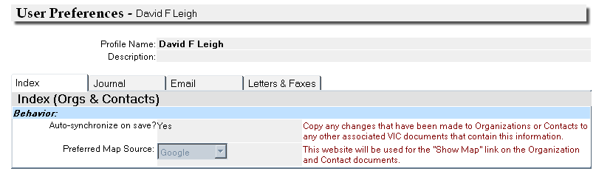Illustration 17: Index Options

Journal
The Journal options allow you to set whether you wish to be prompted before deletions are carried out; whether deletions will move documents to the Trash folder instead; and whether you wish to synchronize VIC with your Notes Calendar.
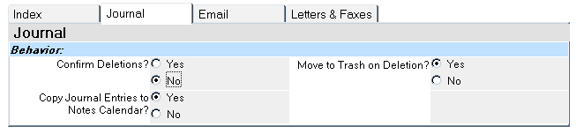Illustration 18: Journal Options
This last point is fairly important. On its own, VIC does not display pop-up remainders for appointments, to-dos and other scheduled activities. Instead, it relies on Notes' Calendar to do that. Be aware that if you don't copy Journal entries to the Notes Calendar, you won't get notifications. Also, if you use a PalmOS device or Blackberry it may synch with your Calendar, but there's no provision for synching it with VIC. Obviously we recommend setting this to 'Yes'.

Email
There are a large number of email options, and these are broken into four tabs; General, Import Options, Replies, and Signature.

General
The only option here allows you to determine what view will be opened when you click on the Inbox icon in the “My Activities” page. Your options are the Lotus Notes Inbox; the My Mail view; the My Mail by Date view; the All Mail view; and the All Mail by Date view.

Import Options
Many of these options are self explanatory. Here's a summary:
- Notify after Import: This will display a dialog box after your mail has been imported. The dialog will show how many documents were imported and how many were moved to the spam folder.
- Allow Agent to Auto-Import: This allows a user to disallow the scheduled agent from retrieving his mail. Otherwise, the agent will retrieve mail from all mail databases that are represented by a User Preferences document.
- Inbox Icon Auto-Imports: If this is set to 'Yes' then clicking on the inbox icon on the “My Activities” page (the envelope) will kick off the importation of mail.
- Import Mail from. This is where you identify the folder where you'll put Lotus® Notes mail that you wish to import. This can be any folder at all, but we'd recommend naming it simply, 'VIC'.
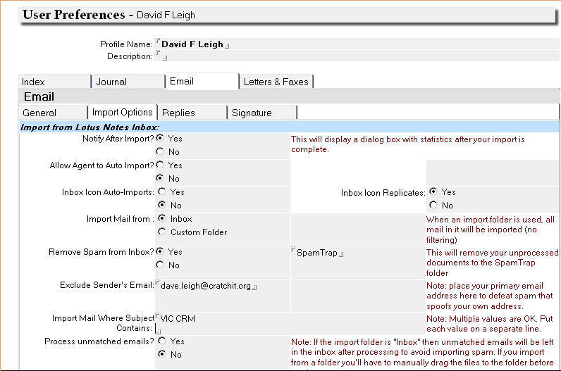Illustration 19: Import Options
You may wish to use the special folder rather than importing directly from your Inbox, since you should check your Inbox for personal mail and unsolicited mail anyway. Manually checking your mail allows you to discriminate between what's imported and what's not. Otherwise you might inadvertently import personal mail that just happens to have been sent by a customer.
- Remove Spam from Inbox? During the import process this will move spam from the Inbox to the folder of your choice. Though you could specify Trash here, it's probably better to indicate a temporary folder that you can sift through every now and again for false positives.
- Import Mail Where Subject Contains: This allows you to specify a list of subject keywords that will cause mail to be imported even if it doesn't match any documents in the Index. It's a handy feature that allows those “in the know” to defeat your spam filter.
- Process unmatched emails? The Import Notes Mail agent can either ignore mails when it can't find a matching email address, or it can go ahead and import them anyway. If you answer “Yes” here then the unmatched emails will appear in your “My Mail” view under the category “-> Imported: To be filed”.

Replies
Here you can determine the format of your replies. You may use Internet Style replies, in which the original message is quoted in-line, and each line of text is preceded by an angle bracket (“>”); and Notes style replies, in which the original message is quoted in a collapsible section. Also, you may have VIC ask you which you would prefer for each individual reply.

Signature
- Automatically insert signature? Answer “Yes” here to have VIC automatically insert the signature that appears in this User Preferences document into any new emails you create.
- Signature: Your preferred signature. You can put anything you like here, but if you want to conform to most Internet standards you should make the first line two hyphens, followed by a space, followed by a carriage return (ENTER). If you've already defined a signature for Lotus® Notes you can save a little bit of typing by clicking the hotspot to import that signature into VIC. Since VIC maintains its signature separately from Notes, it's possible to have separate signatures for your personal (Notes) and your professional (VIC) mail.

Letters and Faxes
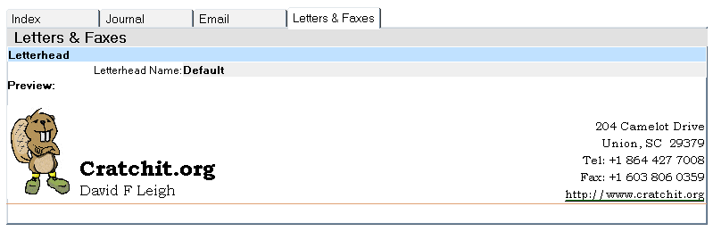Illustration 20: Letterhead options
- Letterhead: Having a personal letterhead (instead of simply referring you to shared letterheads is a handy feature of VIC that allows colleagues with home offices or “loose affiliation” to personalize their letterheads further than plain Notes allows.
Edit the letterhead as described in Letterheads.

Scheduling Agents
Agents are programs that perform tasks for you. A scheduled agent unsurprisingly does this on a periodic timetable. VIC's databases contain a number of agents that can be scheduled to perform routine maintenance for you.
Scheduling agents should be done by your system administrator.

Contract Notification
The Contract Notification agent is intended to run daily, prior to the start of business. Its job is to examine all of the contracts on file and send emails to the people in the notification list when the alarm date or notification date has been reached.
This agent is located in the Contracts database.

Journal Status Update
The Journal Status Update agent runs nightly. Its job is to run through all of the To-Dos in the Journal and change the status to “Overdue” when they are. Certain statuses don't get changed... “Completed” items are left alone, as are “Suspended” items. Overdue items are always shown at the top of the list on today's date.
This agent should be run daily, before the start of business.

Library Document Status Update
Library documents can be “activated” and “expired” on a schedule. This allows you to schedule news items, for example, or expire a product document that refers to a special offer. The Library Document Status Update agent examines the dates on all Library documents and updates the status accordingly. It should be run in the early hours of the morning.

Import Notes Mail (Optional)
The preferred method for importing mail into VIC is to check your Notes Inbox and manually drag the incoming mail to a special folder in your Inbox (you create this folder and tell VIC its name in your VIC User Profile document). It is possible to have VIC automatically import your mail directly from your Inbox or from this special folder, and this can be done on a schedule.
This agent will copy the Emails into VIC, then will move the original to a child folder called “Processed by VIC”. If the child folder doesn't exist then VIC will create it for you. If VIC can't match the sender's email address to an email address in the VIC Index, then the email will be left in the Lotus® Notes Inbox.

Refresh Financial Data
This is only available if you've chosen to customize VIC. It's purpose is to pull information from your accounting system into the Organization Financials fields.

Chapter 11: Resolving Problems
Problems can occur with any program. Here are some ways to resolve some known problems with VIC.
- Can't access the My Activities page.
This can happen when Notes has crashed. To clear the error, open the VIC Configuration database directly from the Notes Workspace, then select “Clear My Activities Flag” from the Actions menu.
An alternate way of clearing this problem is to edit the Notes.ini file with a plain text editor and remove the line beginning with “$CratchitWelcomeOpened”.

Common Public License Version 1.0
THE ACCOMPANYING PROGRAM IS PROVIDED UNDER THE TERMS OF THIS COMMON PUBLIC LICENSE ("AGREEMENT"). ANY USE, REPRODUCTION OR DISTRIBUTION OF THE PROGRAM CONSTITUTES RECIPIENT'S ACCEPTANCE OF THIS AGREEMENT.
1. DEFINITIONS
"Contribution" means:
a) in the case of the initial Contributor, the initial code and documentation distributed under this Agreement, and
b) in the case of each subsequent Contributor:
i) changes to the Program, and
ii) additions to the Program;
where such changes and/or additions to the Program originate from and are distributed by that particular Contributor. A Contribution 'originates' from a Contributor if it was added to the Program by such Contributor itself or anyone acting on such Contributor's behalf. Contributions do not include additions to the Program which: (i) are separate modules of software distributed in conjunction with the Program under their own license agreement, and (ii) are not derivative works of the Program.
"Contributor" means any person or entity that distributes the Program.
"Licensed Patents " mean patent claims licensable by a Contributor which are necessarily infringed by the use or sale of its Contribution alone or when combined with the Program.
"Program" means the Contributions distributed in accordance with this Agreement.
"Recipient" means anyone who receives the Program under this Agreement, including all Contributors.
2. GRANT OF RIGHTS
a) Subject to the terms of this Agreement, each Contributor hereby grants Recipient a non-exclusive, worldwide, royalty-free copyright license to reproduce, prepare derivative works of, publicly display, publicly perform, distribute and sublicense the Contribution of such Contributor, if any, and such derivative works, in source code and object code form.
b) Subject to the terms of this Agreement, each Contributor hereby grants Recipient a non-exclusive, worldwide, royalty-free patent license under Licensed Patents to make, use, sell, offer to sell, import and otherwise transfer the Contribution of such Contributor, if any, in source code and object code form. This patent license shall apply to the combination of the Contribution and the Program if, at the time the Contribution is added by the Contributor, such addition of the Contribution causes such combination to be covered by the Licensed Patents. The patent license shall not apply to any other combinations which include the Contribution. No hardware per se is licensed hereunder.
c) Recipient understands that although each Contributor grants the licenses to its Contributions set forth herein, no assurances are provided by any Contributor that the Program does not infringe the patent or other intellectual property rights of any other entity. Each Contributor disclaims any liability to Recipient for claims brought by any other entity based on infringement of intellectual property rights or otherwise. As a condition to exercising the rights and licenses granted hereunder, each Recipient hereby assumes sole responsibility to secure any other intellectual property rights needed, if any. For example, if a third party patent license is required to allow Recipient to distribute the Program, it is Recipient's responsibility to acquire that license before distributing the Program.
d) Each Contributor represents that to its knowledge it has sufficient copyright rights in its Contribution, if any, to grant the copyright license set forth in this Agreement.
3. REQUIREMENTS
A Contributor may choose to distribute the Program in object code form under its own license agreement, provided that:
a) it complies with the terms and conditions of this Agreement; and
b) its license agreement:
i) effectively disclaims on behalf of all Contributors all warranties and conditions, express and implied, including warranties or conditions of title and non-infringement, and implied warranties or conditions of merchantability and fitness for a particular purpose;
ii) effectively excludes on behalf of all Contributors all liability for damages, including direct, indirect, special, incidental and consequential damages, such as lost profits;
iii) states that any provisions which differ from this Agreement are offered by that Contributor alone and not by any other party; and
iv) states that source code for the Program is available from such Contributor, and informs licensees how to obtain it in a reasonable manner on or through a medium customarily used for software exchange.
When the Program is made available in source code form:
a) it must be made available under this Agreement; and
b) a copy of this Agreement must be included with each copy of the Program.
Contributors may not remove or alter any copyright notices contained within the Program.
Each Contributor must identify itself as the originator of its Contribution, if any, in a manner that reasonably allows subsequent Recipients to identify the originator of the Contribution.
4. COMMERCIAL DISTRIBUTION
Commercial distributors of software may accept certain responsibilities with respect to end users, business partners and the like. While this license is intended to facilitate the commercial use of the Program, the Contributor who includes the Program in a commercial product offering should do so in a manner which does not create potential liability for other Contributors. Therefore, if a Contributor includes the Program in a commercial product offering, such Contributor ("Commercial Contributor") hereby agrees to defend and indemnify every other Contributor ("Indemnified Contributor") against any losses, damages and costs (collectively "Losses") arising from claims, lawsuits and other legal actions brought by a third party against the Indemnified Contributor to the extent caused by the acts or omissions of such Commercial Contributor in connection with its distribution of the Program in a commercial product offering. The obligations in this section do not apply to any claims or Losses relating to any actual or alleged intellectual property infringement. In order to qualify, an Indemnified Contributor must: a) promptly notify the Commercial Contributor in writing of such claim, and b) allow the Commercial Contributor to control, and cooperate with the Commercial Contributor in, the defense and any related settlement negotiations. The Indemnified Contributor may participate in any such claim at its own expense.
For example, a Contributor might include the Program in a commercial product offering, Product X. That Contributor is then a Commercial Contributor. If that Commercial Contributor then makes performance claims, or offers warranties related to Product X, those performance claims and warranties are such Commercial Contributor's responsibility alone. Under this section, the Commercial Contributor would have to defend claims against the other Contributors related to those performance claims and warranties, and if a court requires any other Contributor to pay any damages as a result, the Commercial Contributor must pay those damages.
5. NO WARRANTY
EXCEPT AS EXPRESSLY SET FORTH IN THIS AGREEMENT, THE PROGRAM IS PROVIDED ON AN "AS IS" BASIS, WITHOUT WARRANTIES OR CONDITIONS OF ANY KIND, EITHER EXPRESS OR IMPLIED INCLUDING, WITHOUT LIMITATION, ANY WARRANTIES OR CONDITIONS OF TITLE, NON-INFRINGEMENT, MERCHANTABILITY OR FITNESS FOR A PARTICULAR PURPOSE. Each Recipient is solely responsible for determining the appropriateness of using and distributing the Program and assumes all risks associated with its exercise of rights under this Agreement, including but not limited to the risks and costs of program errors, compliance with applicable laws, damage to or loss of data, programs or equipment, and unavailability or interruption of operations.
6. DISCLAIMER OF LIABILITY
EXCEPT AS EXPRESSLY SET FORTH IN THIS AGREEMENT, NEITHER RECIPIENT NOR ANY CONTRIBUTORS SHALL HAVE ANY LIABILITY FOR ANY DIRECT, INDIRECT, INCIDENTAL, SPECIAL, EXEMPLARY, OR CONSEQUENTIAL DAMAGES (INCLUDING WITHOUT LIMITATION LOST PROFITS), HOWEVER CAUSED AND ON ANY THEORY OF LIABILITY, WHETHER IN CONTRACT, STRICT LIABILITY, OR TORT (INCLUDING NEGLIGENCE OR OTHERWISE) ARISING IN ANY WAY OUT OF THE USE OR DISTRIBUTION OF THE PROGRAM OR THE EXERCISE OF ANY RIGHTS GRANTED HEREUNDER, EVEN IF ADVISED OF THE POSSIBILITY OF SUCH DAMAGES.
7. GENERAL
If any provision of this Agreement is invalid or unenforceable under applicable law, it shall not affect the validity or enforceability of the remainder of the terms of this Agreement, and without further action by the parties hereto, such provision shall be reformed to the minimum extent necessary to make such provision valid and enforceable.
If Recipient institutes patent litigation against a Contributor with respect to a patent applicable to software (including a cross-claim or counterclaim in a lawsuit), then any patent licenses granted by that Contributor to such Recipient under this Agreement shall terminate as of the date such litigation is filed. In addition, if Recipient institutes patent litigation against any entity (including a cross-claim or counterclaim in a lawsuit) alleging that the Program itself (excluding combinations of the Program with other software or hardware) infringes such Recipient's patent(s), then such Recipient's rights granted under Section 2(b) shall terminate as of the date such litigation is filed.
All Recipient's rights under this Agreement shall terminate if it fails to comply with any of the material terms or conditions of this Agreement and does not cure such failure in a reasonable period of time after becoming aware of such noncompliance. If all Recipient's rights under this Agreement terminate, Recipient agrees to cease use and distribution of the Program as soon as reasonably practicable. However, Recipient's obligations under this Agreement and any licenses granted by Recipient relating to the Program shall continue and survive.
Everyone is permitted to copy and distribute copies of this Agreement, but in order to avoid inconsistency the Agreement is copyrighted and may only be modified in the following manner. The Agreement Steward reserves the right to publish new versions (including revisions) of this Agreement from time to time. No one other than the Agreement Steward has the right to modify this Agreement. IBM is the initial Agreement Steward. IBM may assign the responsibility to serve as the Agreement Steward to a suitable separate entity. Each new version of the Agreement will be given a distinguishing version number. The Program (including Contributions) may always be distributed subject to the version of the Agreement under which it was received. In addition, after a new version of the Agreement is published, Contributor may elect to distribute the Program (including its Contributions) under the new version. Except as expressly stated in Sections 2(a) and 2(b) above, Recipient receives no rights or licenses to the intellectual property of any Contributor under this Agreement, whether expressly, by implication, estoppel or otherwise. All rights in the Program not expressly granted under this Agreement are reserved.
This Agreement is governed by the laws of the State of New York and the intellectual property laws of the United States of America. No party to this Agreement will bring a legal action under this Agreement more than one year after the cause of action arose. Each party waives its rights to a jury trial in any resulting litigation.

License copyright © 2005 by the Open Source Initiative

About Cratchit.org
Copyright 2003 - 2005 by David F. Leigh, 204 Camelot Drive, Union, SC 29379 USA.
Rights are hereby granted in accordance with conditions detailed below.

VIC CRM is protected by copyright and distributed under the Common Public License, which restricts its use, copying, and distribution. No part of this product may be reproduced in any form by any means at variance with the accompanying license without prior written authorization of Cratchit.org and its licensors, if any.

This documentation is protected by copyright. No part of this document may be reproduced in any form by any means at variance with the accompanying license without prior written authorization of Cratchit.org and its licensors, if any.


©2003 David F. Leigh

Cratchit.org, the Cratchit.org logo, the cartoon representations of “Vic Beaver” and the “Bob the Business Beaver”, VIC, VIC CRM, “Vital Information Center CRM” are trademarks or registered trademarks of Cratchit.org. Their use is restricted specifically to material specifically related to VIC CRM and in this capacity they may be included in programs, documentation, and marketing material that conform to the above mentioned licenses. Any other use is restricted unless granted by prior written authorization of Cratchit.org and its licensors, if any.

Lotus Notes and Lotus SmartSuite are registered trademarks of IBM, Inc.
Xpedite, OpenOffice.org, Microsoft Word, Microsoft Excel, IntelliView, IntelliPrint, Visioneer, eFax, Crystal Reports and NotesSQL are trademarks of their respective owners.

RESTRICTED RIGHTS:Use, duplication, or disclosure by the U.S.Government is subject to restrictions of FAR 52.227-14(g)(2)(6/87) and FAR 52.227-19(6/87),
or DFAR 252.227-7015(b)(6/95) and DFAR 227.7202-3(a).

THIS DOCUMENTATION IS PROVIDED “AS IS ” AND ALL EXPRESS OR IMPLIED CONDITIONS, REPRESENTATIONS AND WARRANTIES, INCLUDING ANY IMPLIED WARRANTY OF MERCHANTABILITY, FITNESS FOR A PARTICULAR PURPOSE OR NON-INFRINGEMENT, ARE DISCLAIMED, EXCEPT TO THE EXTENT THAT SUCH DISCLAIMERS ARE HELD TO BE LEGALLY INVALID.

** END OF DOCUMENT **

In the real world it's not much different. Your address isn't somehow “different” simply because it appears on your driver's license vs. your tax return. However, your driver's license empowers you to drive, whereas your tax return doesn't.
However, you can only directly associate a person with one organization. If you need to associate more (such as fraternal membership) I'd suggest using the keywords fields for that purpose.
Neat Feature Alert! You'll see a 'Show Map' icon next to each address. Clicking on this will connect your browser to your choice of mapping services. In your Personal Preferences document you can select between Expedia, Google, MapQuest, and MapsOnUs.
When I'm using VIC, the Organization documents contain little more than the name, address, and customer numbers of the organizations. Person documents are where the action is.
You can use the same technique to create child organizations. Highlight the parent, then select Create, then Organization on the Action Bar. The parent information will be filled in for you.
Why two menus? We could have asked you if you want to inherit information. That's the technique used by some competitors. However, we've found that this is a lot faster once you've gotten used to it.
Remember, you could have used the Create menu on the Action Bar to automatically fill in the Account Information from the currently highlighted person, but in this case you'll probably want to start typing as soon as possible. VIC lets you get right down to business and do the associations later. I often find that I can document a call as it's occurring so quickly that the client doesn't even know I'm doing it.
Of course, creating your email using the Action Bar will pre-address it.
As usual you can create a pre-associated fax or letter by using Create on the Action Bar.
http://www.xpedite.com/
http://www.cybernetsoft.com/
http://www.cybernetsoft.com/
http://www.crystaldecisions.com/

